Sl. No. | Application No. | Name | PhD Category | Shortlisted/Not Shortlisted
1 | PHD/ME/2022-2023/0337 | Gracious Arun | Part Time |  | Not Shortlisted**
2 | PHD/ME/2022-2023/0364 | Swagata Dutta | Part Time |  | Not Shortlisted **
3 | PHD/ME/2022-2023/0366 | Aman Deep | Full Time (Regular) |  | Not Shortlisted *#  {Shortlisted in Full-Time (Sponsored/Self-financed)}
4 | PHD/ME/2022-2023/0373 | Manish Kumar Gautam | Full Time (Regular) |  | Shortlisted
5 | PHD/ME/2022-2023/0401 | Deepa Singh | Full Time (Regular) |  | Not Shortlisted *#  {Shortlisted in Full-Time (Sponsored/Self-financed)}
6 | PHD/ME/2022-2023/0431 | Yogeshwaran K | Full Time (Regular) |  | Not Shortlisted *#  {Shortlisted in Full-Time (Sponsored/Self-financed)}
7 | PHD/ME/2022-2023/0443 | Milan Kumar Maity | Full Time (Regular) |  | Shortlisted
8 | PHD/ME/2022-2023/0459 | Selvakumar C | Full Time (Regular) |  | Shortlisted
Department of Mechanical Engineering

List of Shortlisted/Not Shortlisted Candidates for Written Test/Interview for
Ph.D. Admission 2AQ022-23 (Odd)

** Advertisement is only in the categories of Full Time (Regular), Full Time (Sponsored/Self-financed)
* Gate score is not submitted
# Shortlisted for Full-Time (Sponsored/Self-financed)

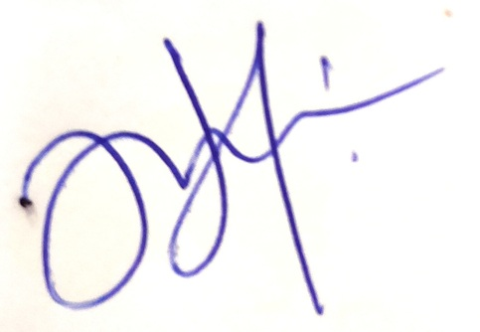

Dr. Saurav Suman Dr. H. Lalhmingsanga
(PG & PhD Co-ordinator, Dept. of ME) (Head of ME Department)

