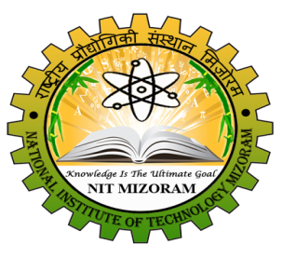 | jk"Vªh; izkS|ksfxdh laLFkku fetksje  NATIONAL INSTITUTE OF TECHNOLOGY MIZORAM  (An Institution of National Importance under Ministry of HRD, Govt. of India)  CHALTLANG, AIZAWL, MIZORAM – 796012
Phone/ Fax: 0389- 2391236 / 0389-2391774 / 0389-2391699 Email: nit_mizoram@nitmz.ac.in

NOTICE

IT IS HEREBY NOTIFIED THAT THE END-SEMESTER SCHEDULE FOR 5TH DECEMBER, 2018 THE FOLLOWING TIME SHALL BE FOLLOWED:

OLD SCHEDULE:
05-12-2018 : 9:30 AM – 12:30 PM
05-12-2018 : 01:00 PM – 04:00 PM

NEW SCHEDULE:
05-12-2018 : 8:15 AM – 11:15 AM
05-12-2018 : 8:15 AM – 11:15 AM

(Dr. K. Gyanendra Singh)
Faculty i/c – Examination

